2025北京国际影偶艺术节参演剧目报名表
Show Entry Form of 2025 Beijing International Puppet Festival

作品名称  Name of the play |  |  | 国家/城市  Country/City
演出团体  performing group/individual artist |  |  | 作品时长  Duration of the play
作品类别  Type of the play |  |  | 语言  Language
适宜观演人数  Suggested number of audience |  |  | 建议观剧年龄  Suggested age of audience
演出人数
（仅限演员及必要技术人员）
Number of performers
(Actors/actresses and necessary technicians only)
报名组别  Category of application | ☐剧场展演单元 Theatre Performance Unit  ☐线上展映单元 Online Screening Unit  ☐户外表演单元 Outdoor Performance Unit
剧团简介
Introduction to the group

剧情简介
Plot Introduction
作品构思及艺术特色
Concept and artistic features of the play
奖项及荣誉
Awards and honors
(Optional)
媒体/观众评价
Media/audience comments
主创团队
List of main creators

艺术家简历
Artist Resume
道具运输  Prop transportation  （注：仅限必要的演出道具）  (Necessary props for the performances only) | 行李件数  Luggage number
 | 是否含超常规行李  Irregular baggage included or not | 是 Yes 否 No
超常规行李明细
（尺寸/重量）
Details of the irregular baggage
(size/weight)
装台时间  Set-up time |  | 是否需要技术支持  Need technical support or not |  |  |  | 灯光编程  Lighting programming  音响控制  Sound controling  舞台搭建(特殊平台)  Stage setting (special platform)  否 No
撤台时间
Take-down time
联系人  Representative |  | 职务  Position
电话  Cell phone |  | 邮箱  E-mail address
网址  Website |  | 社交账号  INS/Facebook

注：
Note:
1.上述内容请提供英文版。
1. Please provide the English version of the above content.
2.请另附舞台技术清单及灯位图。
2. Please attach the stage technique list and the lighting plot.
3.作品相关其他宣传资料，欢迎补充。
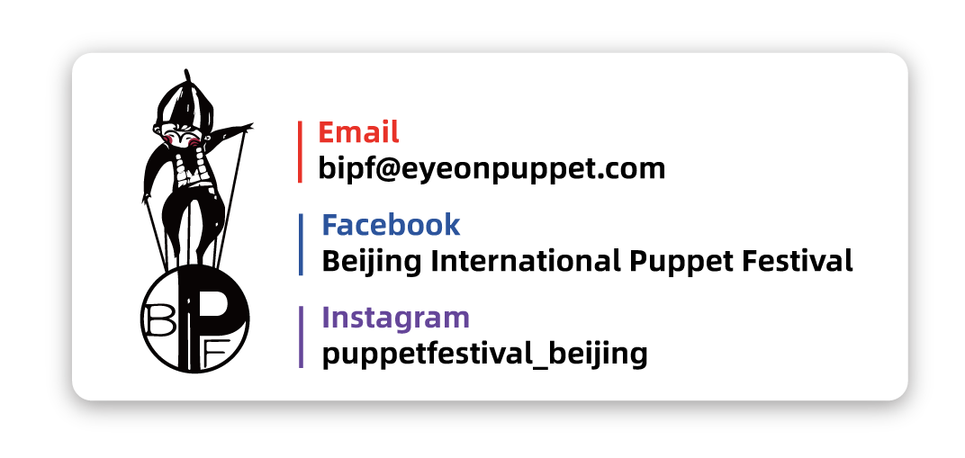
3.Other promotional materials related to the work are welcome to be added.

